Growing Marriages
Ephesians 5:31-33

Session
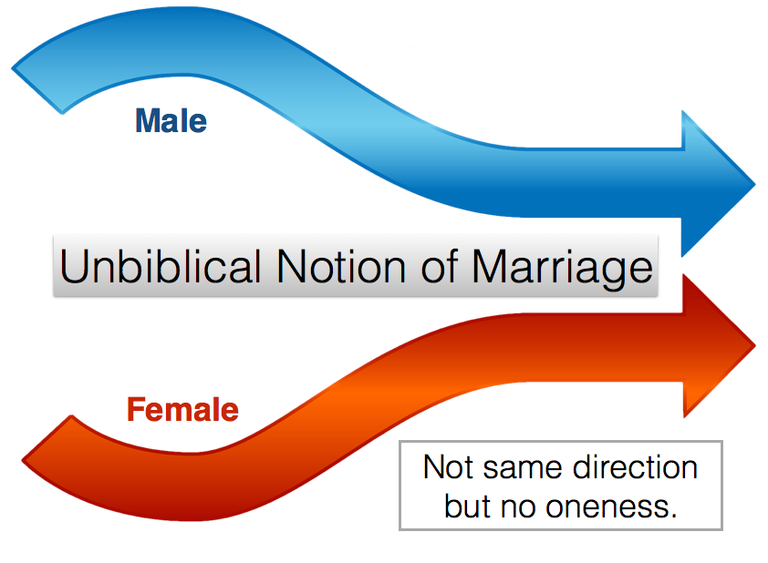
Marriage binds us in covenant to another until death bids us apart and therefore enables us to more deeply refine ourselves and our relationship with our spouse. As we grow in our understanding of God’s commitment to bless our marriage, we further deepen our commitment to our spouse and love him/her as God loves us.

A Biblical Picture of Marriage (Eph 5:31-33)
“31 For this cause a man shall leave his father and mother, and shall cleave to his wife; and the two shall become one flesh. 32 This mystery is great; but I am speaking with reference to Christ and the church. 33 Nevertheless let each individual among you also love his own wife even as himself; and let the wife see to it that she respect her husband” (Ephesians 5:31-33).

31: Marriage is ____________: God’s statement on the essence of marriage.

32: Marriage is a ____________: A reflective design after the eternal pattern between God and His people.

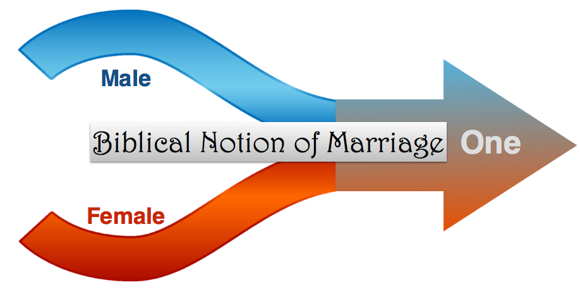
33: Marriage is ____________: The concepts of marriage must be translated to our lives.

A Framework for Marriage
God’s design and framework of marriage lead to the beauty of intimacy. The two become one flesh, physically, yes, but also in one’s soul and purpose. This ‘oneness’ becomes the driving conviction that enables one to work through the growing process of marriage. The beauty and joy of marriage come to full bloom as this ‘one flesh’ is worked out in the two.

The Makings of a Great Marriage - an illustration
- The process of cooking
- Necessity of heat
- Intimacy creates that friction/heat/troubles
- A blend is best; two become one
This growing process of marriage is tied up to our own personal spiritual development. We can look at it negatively (the losing) or positively (the gaining and refining). Marriage, then, is this refining experience offering great rewards. When we are conscious of the losing, as in a genuine discipleship relationship (i.e., dying to ourselves), we then can work along the process and not blame our spouses or God or others for the trouble. Instead, we eagerly look forward to that designed ‘oneship’ for our relationship. Let’s follow marriage through three levels.

Level 1 - Commitment and Openness

Vision: I want to be with him/her!
Think of the financial costs, pressures, changes of roles, living locations that occur when a couple gets married, and yet they still want to be married!

Honeymooner’s Changing vision
- Committed
- Desirous
- Commitment often subtly built on one’s expectations.

Honeymooner’s Challenges
- Unstable and love is unstable
- Hopes dashed
- Hopes regained (make-up)

Honeymooner’s Reactionary Responses
- Gives up (usually temporary) on one’s mate - emotionally and physically
- Accepts lower expectations for a time (living by feelings rather than truth - oneness)
- Drops kind behavior and accepts less than acceptable words and actions

Summary
The early stage of marriage often is an expression of ‘eros’ love. Although this fatuous love is committal in nature, the commitment tends to be based upon on one’s expectations and fulfilled dreams. When the expectations do not pan out, then great ups and downs occur.

Level 2 - The Challenging Steps to Keep a Marriage Growing

Vision: Pursue God’s goals of marriage despite temporary setbacks
The hopes of marriage are charged by a deep commitment to God’s hopes that He gives one in His Word lest one regress from the oneness obtained and step back into a focus on one’s own wants and desires.

Young Married Couple’s Changing Vision
- Love: I do love being married, but…
- Lost temper: I get really upset with my spouse.
- Lose vision: is this all there is to marriage?

Young Married Couple’s Characteristics
- Compromise: I am willing to put my ambitions ahead of our relationship.
- Devious: I fake genuine love to get what I want.
- Adulterous: Entertain thoughts of other relationships as better.

Young Married Couple’s Challenges
- Needs to allow God’s Word to bring one to Him to retain that vision and commitment.
- Prayerfully work through difficulties and impasses in the marriage relationship.
- Persistently forgive one another and trust God to meet one’s deepest needs.

Summary
God’s Word gives hope and direction for the confused couple about their future days together. Marriage works when one allows God to work through the misunderstandings and make-up times. The young married couple often lives out a worldly ‘phileo’ love, “As you treat me, I will treat you.” These are times one’s rough places are being rubbed off and ‘agape’ begins to shine.

Level 3 - Mature Responses from God’s Love

Vision: A steady devotion towards one’s spouse
Christ’s love is a maturing love, further refining our attitudes, words, and touches enabling us to love those who differ from us or would otherwise cause insecurity in our marriage.

Mature Married Couple’s Consistent Love
- I make sacrifices for him/her.
- Sometimes, I am so busy serving my spouse, I forget myself.
- When I am wronged, I can usually quickly forgive.
- The issue is not to get my way, but to see what God is teaching me through my spouse.
- I am trying to discover the needs of my spouse so that I can delight him/her.

Mature Married Couple’s Characteristics
- Relationship with God is stable so the relationship with one’s spouse is stable even when there are misunderstandings, disappointments or different expectations.
- Increasingly intimate times with one’s mate are not based on beauty but devotion, not on physical intimacy alone but heart oneness.
- One continues to deepen one’s relationship with God to unfold deeper insights into God’s love, enabling one to further refine his or her love to one’s spouse as guided by the Spirit.
- Devoted to being completely content with one’s own spouse.

Summary
An enriching ‘agape’ love enables the mature believer to avoid selfish binges and demands, and instead focuses on building up one’s mate through consistent and kind acts and words, delighting in the resulting oneness of heart and mind bringing peace, joy and love.

Questions
- Think of a troubled marriage and point out how personal/spiritual problems affect their marriage.
- Have you ever seen a great marriage? What characteristics have you seen of these good marriages?
- Identify one or more personal qualities in your life that need to be worked on to have an intimate marriage. How might each affect one’s marriage?

