
Oakland International Fellowship Paul J. Bucknell

Our Hunger for God’s Lessons (Mark 6:30-44)
A Handout
The clash between our spiritual and physical drives is great, though our physical drives were originally designed to work in harmony with our spiritual drives. Much of our lives, like the disciples, is mastering how to consistently do and so become good disciples of Jesus Christ. The constant demands provided many opportunities for them to learn how to prioritize their spiritual sensitivities.
A) The Test of Circumstances: _______ and _______ (Mark 6:30-34)
30 And the apostles gathered together with Jesus; and they reported to Him all that they had done and taught. 31 And He said to them, “Come away by yourselves to a lonely place and rest a while.” (For there were many people coming and going, and they did not even have time to eat.) 32 And they went away in the boat to a lonely place by themselves. 33 And the people saw them going, and many recognized them, and they ran there together on foot from all the cities, and got there ahead of them. 34 And when He went ashore, He saw a great multitude, and He felt compassion for them because they were like sheep without a shepherd; and He began to teach them many things.
- “Apostles” (30) is only used here in Mark, an apt description for the 12 that Jesus sent forth. The significance of apostle is not in the person but in the invested authority and power from the one who sent them–Jesus. “He summoned the 12 and began to send them out in pairs” (6:7). God ____ equips us for our _____.
- “They reported” (30) shows the Lord’s expectations of them and us, having expectations and making us accountable. How are we doing in understanding and _______ out what God has purposed us to do?
- “Rest a while” (31) depicts how we can get so busy with life and ministry that we must purpose to spend time with Jesus. Miraculous incidents become cataracts of the soul if time isn’t spent with God.
- The crowds “got there ahead of them” (33) points out that, at times, although needing ____, we really need great trust God to be able to see and care for the compelling needs of those around us.
Examples: A spouse’s harsh remarks? A child’s bad day?
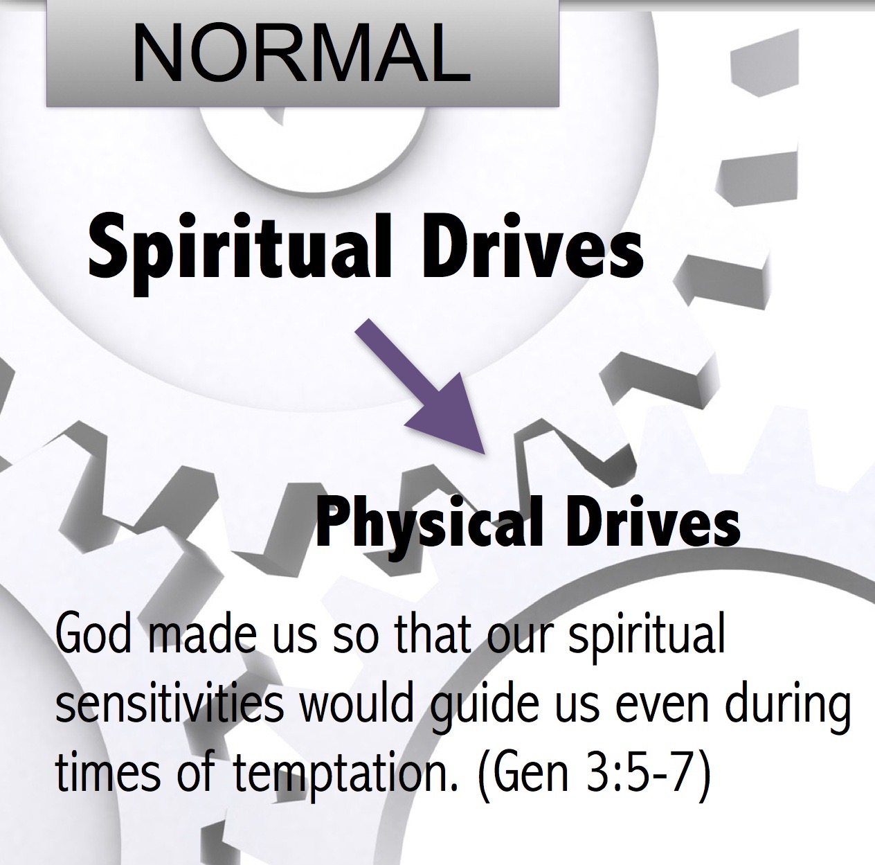
- “He went ashore” (34) shows Jesus’ commitment and willingness to place the needs of others over His own, while the phrase “He felt ________” shows us the mindset that is needed to rightly minister to others without being ensnared in the devil’s attempt to use glory and power to poison our ministries.
- “He began to teach them many things” (34) even when it was already quite late, displaying the great hunger of God’s people. Their rapt attention to the Word of God overcame their physical appetites. Anytime our spiritual drive is overdriven by our physical desires, we become susceptible to the lusts of deceit (Eph 4:22).
Test #1 Test of Trust
At times, our surrounding needs ______ us beyond ourselves, but we don’t know what is in us or what God can do until we are greatly challenged.
Test #2 Test of Pride
We can be tested at any moment, even at our greatest points of _________________.
Summary: Our daily lives, if rightly understood, are a conglomeration of spiritual battles, giving us opportunities to live by faith and win. They also serve as a test to see whether we will reject God’s ways and depend on our own solutions apart from God, resulting in embarrassing failures.
B) The Purposed Test by Jesus: Trust (Mark 6:35-44)

35 And when it was already quite late, His disciples came up to Him and began saying, “The place is desolate and it is already quite late; 36 send them away so that they may go into the surrounding countryside and villages and buy themselves something to eat.” 37 But He answered and said to them, “You give them something to eat!” And they said to Him, “Shall we go and spend two hundred denarii on bread and give them something to eat?” 38 And He said to them, “How many loaves do you have? Go look!” And when they found out, they said, “Five and two fish.” 39 And He commanded them all to recline by groups on the green grass. 40 And they reclined in companies of hundreds and of fifties.
41 And He took the five loaves and the two fish, and looking up toward heaven, He blessed the food and broke the loaves and He kept giving them to the disciples to set before them; and He divided up the two fish among them all. 42 And they all ate and were satisfied. 43 And they picked up twelve full baskets of the broken pieces, and also of the fish. 44 And there were five thousand men who ate the loaves.” (35-44; NASB)
- “Already quite late” (35) shows the reason they were trying to politely take control of what could be a disastrous mess. Their suggestion wasn’t bad, but it was missing God’s greater purposes.
Worry is known for failure in trusting God’s _______ and _______.

- “You give them something to eat!” (37) really startled them. Where would they get that great amount of money to feed everyone? One denarius is equivalent to a day of work (today’s 2/3 annual salary).
- Personal testimony of worry. On my first trip to India I started to fall into worry. I remember walking back and forth in my backyard, wondering how I was going to pay for the trip and ministry to India, then….
- “How many loaves do you have? Go look!” (38) shows us that God usually takes what we have and transforms it so that it becomes sufficient. God in His divine wisdom has placed what we need when we need it so that we can always carry out His will.
- “He blessed the food and broke the loaves” are two important steps. The blessing of God on what we presently have changes what we have. While desperately running around for nutritious food, we can forget to believe God can bless our food for His greater _________.
- “He broke the loaves” (41). What do you think the disciples and people were thinking about when Jesus started breaking and distributing the loaves and fish? What was Jesus believing? Jesus knew God heard.
Summary:
Christ has entered the world, calling us all to fix our hope in Christ and to consider living in light of His Lordship and His second coming. He has both His purposes and ways.
Conclusion
We live by God’s grace. The more we perceive this need, the more we depend on Him. This dependence is the outworking of our faith. Our hunger for God is that deep craving for God’s fullness in our lives. “The LORD is good to those who wait for Him, To the person who seeks Him” (Lam 3:25).

Discussion Questions
- Share about a time you felt ‘burned-out’? Were you close to the Lord or not? Explain.
- How did Jesus get extra strength for the demanding crowds who wanted His attention? Do you ever face such demands on you? How do you handle them? What can we learn from Jesus?
- Why does worry keep us from seeing God’s miracles?

