
Oakland International Fellowship Paul J. Bucknell

An Introduction to Mark (Mark 1:1-15)
A Handout
Mark, one of the three synoptic Gospels, closely traces the people’s growing awareness of Jesus Christ. While some harden their hearts, especially as He draws near to Jerusalem at the end of the book, many others realize who He is and try to come to terms with what it practically means for them to follow Jesus.

A) Facts of the Gospel of Mark
- John Mark, Peter’s assistant, wrote this earliest gospel from Rome, though not sure before or after Peter’s death (around 66 A.D.).
- John is chiefly concerned with properly presenting Jesus’ identity (Son of God; Christ) and ministry (Son of Man) to describe His essential saving ministry, making a strong stress on action which sets this Gospel apart. The word “immediately” is used 39 times in Mark’s 16 chapters (largely before chapter 10).
- Affirmation by Papias (60-130 A.D.), bishop of Phrygia says, John Mark “…Wrote down accurately, though not indeed in order, whatever he remembered of the things said or done by Christ. For he neither heard the Lord nor accompanied him, but afterward, as I said, he was in company with Peter…but with no intention of giving a connected account of the Lord’s discourses.” –Ancient Christian Commentary on Scripture, Vol 11, p. xxi.
- Healing Theme:
A. Healing with Miracles (ch. 1-6) Miracles prove Jesus’ power, but can’t fully satisfy the need of people’s hearts.
B. Healing of Heart (ch. 7) Our hearts depict our affections and loyalty, following Jesus to the cross.
C. Healing from Sin (ch. 8-16) The gospel reveals the curse of our sin, belief, and hope in Christ’s resurrection.
- Gospel or Theological Theme:
  - Mark 1-8 Divine Proof of the Son of God
Mark starts off with a startling claim–Jesus the Son of God, Messiah. This claim of deity and power stood in great contrast to the Roman deities back then as well as humanism and other powerful people today. On what basis does Jesus make this claim and what affects does it have on our personal lives? This is what the first part of Gospel of Mark is all about!
  - Mark 9-16 Divine Work of the Son of Man
The speed and scenes of the first part of the book drastically slow down in this last half of the Gospel of Mark where the camera zooms in on what Jesus was doing or allow to have done to Him. How and why is the powerful Jesus now acting so weak and victim-like? Join us in this important study on Jesus, the Son of Man.
Summary: The earliest Gospel makes a startling presentation of Jesus Christ calling for our attention and life.
B) John the Baptist - a forerunner (Mark 1:1-15)
The beginning of the gospel of Jesus Christ, the Son of God. 2 As it is written in Isaiah the prophet, “BEHOLD, I SEND MY MESSENGER BEFORE YOUR FACE, WHO WILL PREPARE YOUR WAY; 3 THE VOICE OF ONE CRYING IN THE WILDERNESS, ‘MAKE READY THE WAY OF THE LORD, MAKE HIS PATHS STRAIGHT.’” 4 John the Baptist appeared in the wilderness preaching a baptism of repentance for the forgiveness of sins. 5 And all the country of Judea was going out to him, and all the people of Jerusalem; and they were being baptized by him in the Jordan River, confessing their sins. 6 And John was clothed with camel’s hair and wore a leather belt around his waist, and his diet was locusts and wild honey. 7 And he was preaching, and saying, “After me One is coming who is mightier than I, and I am not fit to stoop down and untie the thong of His sandals. 8 “I baptized you with water; but He will baptize you with the Holy Spirit.” (1-8; NASB)
- “The beginning” introduces Jesus as the Messiah (lit. Christ), even the Son of God, instantly raising many questions and sets the plot of the gospel, “Who is Jesus and what does He have to do with me?”
- “I send My messenger” (2) identifies John the Baptist as God’s prophet with a role to “prepare your way.”
- “Make ready the way of the Lord” (3) from Isaiah 40:1-3 shows the entrance of Jehovah (OT:Yahweh-NT: kurios) into the world’s scene.
- “The wilderness” (4) insists on the fulfillment of a prophecy of the new eschatological era (Is 40:1-3) marked by the “glory of the Lord” (Is 60:1-3) (shekinah glory) where God will renew His covenant (Hos 2:14-23).
- “Preaching a baptism of repentance” (4 kerusso) calling people to turn from their sins, preparing their hearts.
- “For the forgiveness of sins” (4) becomes a key theme of Mark stemming from Isaiah 40:1-3’s message. It is the time for comfort, a turn from God’s silence (400 years since Malachi), and God’s willingness to forgive, initiating a new era and hinting at Christ’s own purpose of coming to die for our sins.
- “One is coming” (7) points not to John, nor to the thousands baptized, but to Jesus - the Son of God.
Summary of 1:1-8: John, a powerful preacher, though an intriguing prophet, quickly turns the attention from his life to Jesus’ mission to prepare the people for God’s visitation with Jesus as Messiah, the Son of God.
9 In those days Jesus came from Nazareth in Galilee and was baptized by John in the Jordan. 10 Immediately coming up out of the water, He saw the heavens opening, and the Spirit like a dove descending upon Him; 11 and a voice came out of the heavens: "You are My beloved Son, in You I am well-pleased.” 12 Immediately the Spirit impelled Him to go out into the wilderness. 13 And He was in the wilderness forty days being tempted by Satan; and He was with the wild beasts, and the angels were ministering to Him. 14 Now after John had been taken into custody, Jesus came into Galilee, preaching the gospel of God, 15 and saying, "The time is fulfilled, and the kingdom of God is at hand; repent and believe in the gospel."
- “The Spirit like a dove descending upon Him” is God’s anointing (the voice) by the Spirit for His service.
- “My beloved Son” (11) shows the distinguished role of the ‘Son of God’ bringing God’s presence to earth.
- “The Spirit impelled Him to go” (12) is Jesus’ first mission to face Satan who stole man’s heart from God.
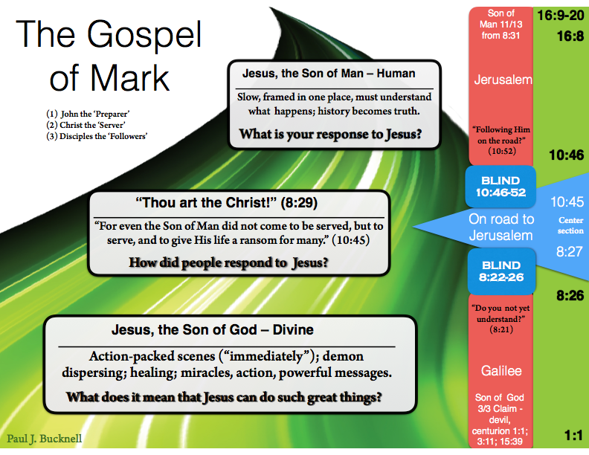
- “The time is fulfilled” (15) highlights the new era where the kingdom of God is established and continues to grow by the message of repentance and belief in the gospel (lit. good news).
Summary of 1:9-15: Christ has entered the world, calling us all to fix our hope in Christ and to consider living in light of His Lordship and His second coming.

C) Mark’s Big Picture
- The road
- The plan
- The hope
Mark is introducing Christ to the world that all might believe Him and find eternal life–preach the Gospel.

Discussion Questions
- Do you think you would prefer watching the people being baptized by John–including Jesus, or standing by the hill where Jesus was crucified? Why?
- How did John the Baptist get people ready for Jesus? Why is the repentance part so important?
- So who would you say Jesus Christ is? How would you back up your claim?

