OIF Paul J. Bucknell

Israel’s Future and God’s Wisdom
Romans 11:25-36 Handout
God’s promises are important. If God was not faithful in His promises to Israel from the past, what confidence would we have towards His promises regarding salvation? This passages shows how everything is perfectly working along God’s glorious schedule, even fulfilling His promises to treacherous Israel.

God’s Abundant Mercy (Romans 11:25-32)
^{11:25} For I do not want you, brethren, to be uninformed of this mystery, lest you be wise in your own estimation, that a partial hardening has happened to Israel until the fullness of the Gentiles has come in; ²⁶ and thus all Israel will be saved; just as it is written, “THE DELIVERER WILL COME FROM ZION, HE WILL REMOVE UNGODLINESS FROM JACOB.” ²⁷ “AND THIS IS MY COVENANT WITH THEM, WHEN I TAKE AWAY THEIR SINS.” ²⁸ From the standpoint of the gospel they are enemies for your sake, but from the standpoint of God's choice they are beloved for the sake of the fathers; ²⁹ for the gifts and the calling of God are irrevocable. ³⁰ For just as you once were disobedient to God, but now have been shown mercy because of their disobedience, ³¹ so these also now have been disobedient, in order that because of the mercy shown to you they also may now be shown mercy. ³² For God has shut up all in disobedience that He might show mercy to all. (NASB used)

Three stages of mercy in God’s redemption plan (Eschatology in Romans)
Israel’s hardening  Stage #1 | Gentiles saved  Stage #2 | Israel saved  Stage #3
“... a partial hardening has happened to Israel” (25) | “... until the fullness of the Gentiles has come in” (25) | “... and thus all Israel will be saved” (26).
Israel’s hardening is evident. The number of Jewish believers was soon surpassed by Gentile believers. The Jews, hardened in heart, did not as a nation embrace the Messiah. The hardening is partial in that we can anticipate some positive response to the gospel from the Jews. | The hardening became the means by which the Gentiles could be saved (32). The flow of God’s mercy is, for a time, diverted to the Gentiles. The fullness could refer to all the nations being reached or to the “fulfillment” where the Jews would join in and finish the task (cf. 11:11-12). | Since Paul has effectively shown not all the Jews would be saved, he must not be referring to the nation Israel as a whole. The phrase, “all Israel.” probably refers to the whole olive tree (11:17)–all the chosen people of God, including both Jews and Gentiles (cf. Eph 3:1-13).

- “And this gospel of the kingdom shall be preached in the whole world for a witness to all the nations, and then the end shall come” (Mt 24:14).
- “And they will fall by the edge of the sword, and will be led captive into all the nations; and Jerusalem will be trampled under foot by the Gentiles (Greek: ethnon) until the times of the Gentiles (same: ethnon) are fulfilled” (Luke 11:24).
- “For the gifts and the calling of God are irrevocable” (Ro 11:29) speak of God’s promises to Israel.
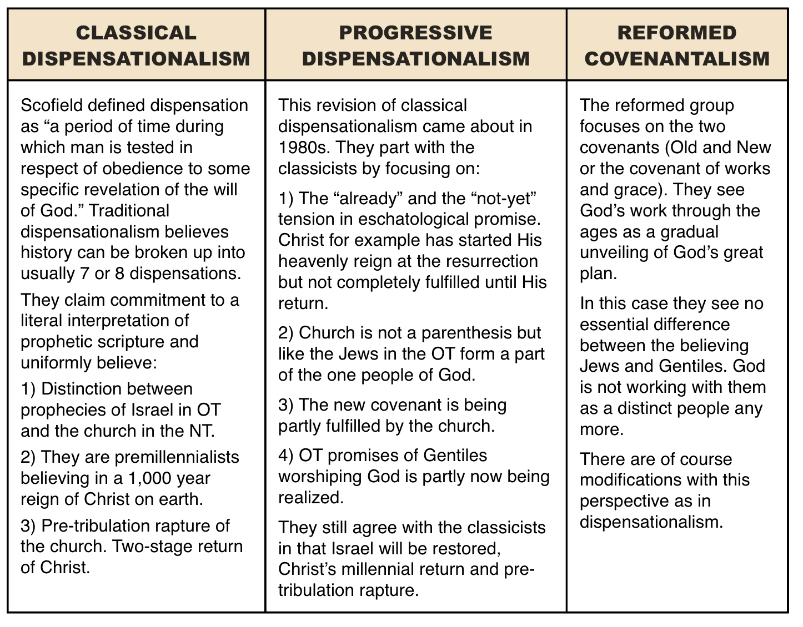
- Summary: Paul’s whole argument shows that God has not forsaken the Jew. One could, like Calvin, assume that the Jews are merely merged with the Gentiles into one new Israel (picture of one tree). However, Paul several times refers to a great blessing that will come when the Jewish people believe (11:12,15). If he uses this approach to further his main argument, then it seems necessary to accept the viewpoint that God will do some future special work in Israel as a cultural people, just as the Lord has done with each nation. This would demonstrate God’s ultimate mercy and grace – by not only sparing the rebellious Jews but greatly using them! Moses’ words seem to confirm this, “When you are in distress and all these things have come upon you, in the latter days, you will return to the LORD your God and listen to His voice” (Dt 4:30).
- Israel, then, will be the last nation that the Lord comes to visit before His return. It is likely that God will soften the heart of the Jews and mightily use them to finish or at least greatly strengthen the kingdom of God throughout the world.

B) God’s Awesome Glory (Romans 11:33-36)
³³ Oh, the depth of the riches both of the wisdom and knowledge of God! How unsearchable are His judgments and unfathomable His ways! ³⁴ For WHO HAS KNOWN THE MIND OF THE LORD, OR WHO BECAME HIS COUNSELOR? ³⁵ Or WHO HAS FIRST GIVEN TO HIM THAT IT MIGHT BE PAID BACK TO HIM AGAIN? ³⁶ For from Him and through Him and to Him are all things. To Him be the glory forever. Amen.
- In order to understand the universe, we need to see that all things were created for Him, exist through Him, and are ultimately designed to carry forth His purposes. No boredom here!
- Are there situations that confound the Lord?
- Is it right to ever blame God?
- Can we really understand God?
- Can our Christian growth ever max out?
- Is any problem too hard for the Lord to solve?
- Is it ever right to think that God owes us something?
- God’s attributes (33-35): God’s wisdom, knowledge, judgments, ways. (See sidebar)
- God’s attributes (36a): “For from Him and through Him and to Him are all things.” God’s sovereignty and the universe (i.e. everything spiritual and matter)
- God’s attributes (36b): “To Him be the glory forever. Amen.”
- The gospel, then, displays God’s mighty wisdom through the way He implements even a greater salvation plan through those who resisted His ways. Though He brought proper judgment upon His people for their hardened hearts, all His promises and His greater redemptive plan come to fruition.
- Anyone who sides against Him will ultimately be greatly frustrated.
- As we affirm God’s person and purposes, our faith is built up, and the mighty Spirit of God rises up through our lives, no matter how great the evil of the world looms about us.
Summary
Like the end of Job, a bright blast of God’s glory shines into our confusion, keeping us from quickly dismissing His promises as impossible and subduing our doubts regarding His good purposes for our lives.
Discussion questions
- What are some signs of the ends of the age and how should this help shape our lives?
- Presently, God is exercising His great mercy. Do you think there is a chance to gain mercy after death if it rejected now? On what basis do you answer this?
- There are many things that we do not understand. How does Ro 11:36 help take us that further step where we can trust our Maker with all the events that have or will occur? What is one area of life that you have difficulty trusting Him with?

