Oakland International Fellowship Paul J. Bucknell

Revelation 20 Handout
Special Session on The Millennium (Revelation 20:1-15)
The thousand-year era is only mentioned here in Revelation 20, but this passage has come to possess great influence over the interpretation of the whole Book of Revelation as Blevins describes it, “The tail that wags the dog.” Three major interpretations of Revelation 20 greatly influence a person’s eschatology (study of end times).
“Bound him (Satan) for a thousand years” (Rev 20:2).

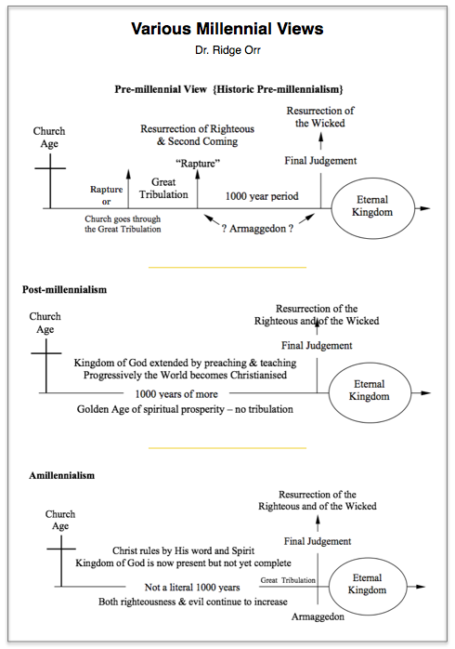
A. Different Views of the Millennium
Christians over the ages have held to different millennial views. This is not a matter of orthodoxy but of preparedness, which considering the message of Revelation is important, “Blessed is he who reads and those who hear the words of the prophecy, and heed the things which are written in it; for the time is near” (Rev 1:3).
Premillennialism (Chiliasm–1000 years)
Premils identify the millennium to be a promised literal 1000 years of promised peace and blessing for some saints and other glorified ones before Armageddon, final judgment and the eternal age. Premils vary on a pre-trib, mid-trib or post-tribulation rapture.
Postmillennialism
Seeing that the judgments/tribulation were fulfilled in the Roman conquest of Israel in 70 A.D., the non-literal millennium describes the present age of the propagation of the gospel going forward, resulting in an increasing sanctified and improved global community before Christ returns.
Amillennialism
Amils believe that the symbolic millennium is another way for the Book of Revelation to describe the church era with the clear purpose of spreading the gospel to the nations. This age will close by a brief release of Satan, renewed persecution, final judgment, second coming of Jesus and promise of new world.

Summary
The willingness for all of these believers to put their faith in God’s Word to shape their worldview is admirable. The premils have overcome the liberal’s disregard for the scriptures by tenaciously holding onto the soon appearing of Christ. The postmils impressively believe in the success of the gospel to positively influence the society while the amils stress Christ’s powerful redemption message proclaimed to the world (nations).

B. A Literal or Symbolic Millennium?
^{20:1} And I saw an angel coming down from heaven, having the key of the abyss and a great chain in his hand. 2 And he laid hold of the dragon, the serpent of old, who is the devil and Satan, and bound him for a thousand years, 3 and threw him into the abyss, and shut it and sealed it over him, so that he should not deceive the nations any longer, until the thousand years were completed; after these things he must be released for a short time. (Rev 20:1-3)
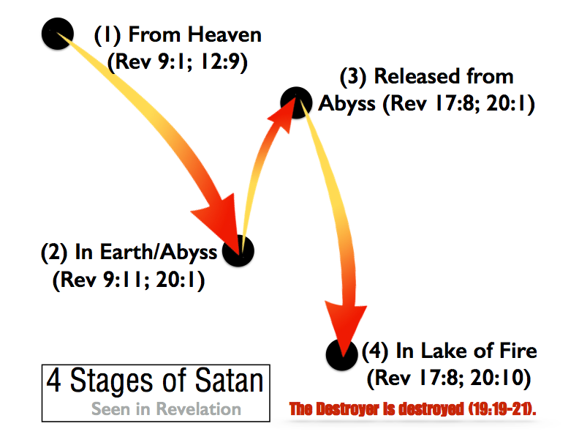
Which millennial viewpoint is biblically correct? Postmils and Amils both support a figurative 1000 year period closely identified as the time between Christ’s comings while Premils a literal 1000 years.
- Postmils, however, cannot easily link all NT tribulation and evil with Israel’s 70 A.D. judgment (e.g. Rev 2-3; 2 Th 1:5-10;2:2-11) nor give evidence for decreasing evil in society even though God’s kingdom is growing.
- Premils’ only support for a literal 1000 years depends on: literal numbers, a shaky chronological order, and Messianic promises (Point C).
  - Numbers in Revelation are not necessarily meant to be literal (e.g. 7 churches–1:20,2:1– represent the whole church; 24 elders the church-4:4,10;14;3;19:4; 144,000, etc.) while some hold all numbers in Revelation to be symbolic. One should not prove a point by this.
  - Non-chronological markers: “After these things” (7 times: Re 4:1; 7:9; 9:12;15:5;18:1;19:1;20:3). “And I saw” (27 times) or “And I heard” (17 times) all encapsulate recapitulated events and sequences not in historical chronology but indicative of what John saw.
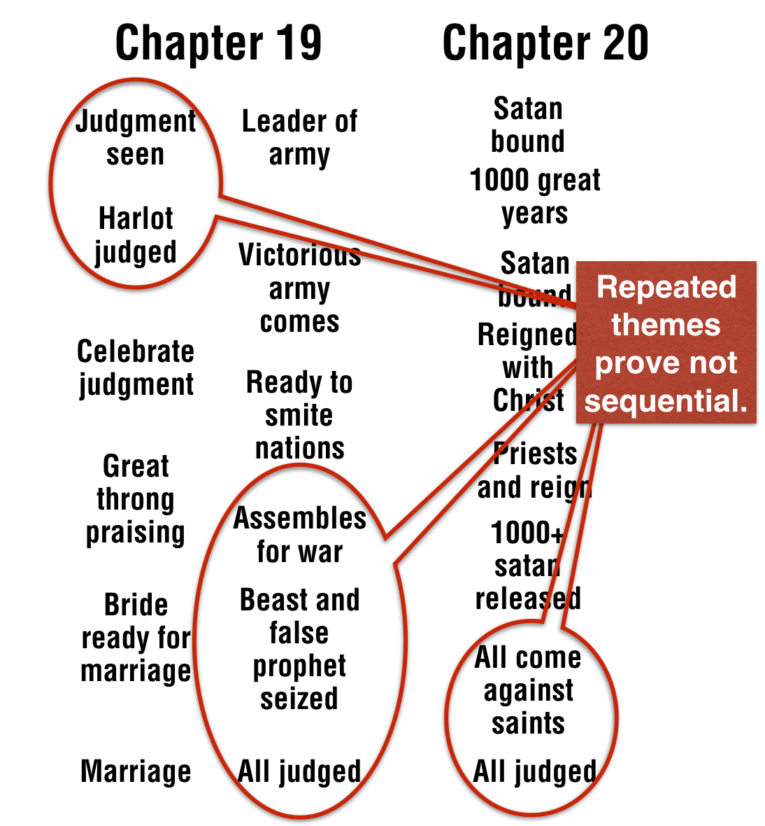
  - Style: Chiastic diagrams necessarily supersede chronology patterns. Moreover, the ‘seven’ seals, trumpets, bowls obviously overlap each other, emphasizing style over timing. Each set of scenes presents an unfolding and yet more complete set of prophecies on both good and evil events, whether on the earth or in the spiritual realm. Rev 20, being closer to the end, again describes in parallel sequence the concluding earthly and heavenly events but in a much more intense and climatic way.
  - Doctrinal conflict can arise when one asserts the millennium events are distinctive from anything that happens prior or afterwards such as Satan’s lost of authority or regaining of it (Lu 10:17-19; see chart).
  - Recapitulation: If one millennium event happens outside of Rev 20, then millennium history is no longer distinct but another re-picturing of the same themes: judgment, Satan’s binding, marriage, victory, etc.

C. Interpreting Old Testament Eschatological Promises
The Old Testament forecasts many scenes of the coming promised Messianic age. Premils demand the need for a literal millennium for their fulfillment, but Jesus (Mat 25) and the apostles (2 Th 1-2; 1 Cor 15:51-53; 2 Pe 3:1-13) affirmed these prophesies to be fulfilled in Christ’s kingdom in the church or in the eternal age: “According to His promise we are looking for new heavens and a new earth, in which righteousness dwells” (2 Pe 3:13).
  - Ezekiel 39:9’s reference to a huge victory gathered from the north (Gog) against God’s people (Rev 14:18-19; 16:14,16; 20:8). Revelation identifies its markers (Gog, Magog), sometimes joins with other markers like Har-maggedon and points to its ultimate historical fulfillment with no hint of a millennium.
  - Ps 2:9 (Rev 19:15): “Thou shalt break them with a rod of iron, Thou shalt shatter them like earthenware” (Ps 2:9) clearly indicates a powerful victory (i.e. smashing) rather than the need for a 1000 years for Jesus to rule with an iron rod, since He now reigns (Rev 1:6;2:8;4-5;6:1;11:15-16).
  - Zechariah 14:1-9 certainly speaks of a great battle against Jerusalem, an earthquake and unique lights of the heavens which could graphically (and partially) be fulfilled in 70 A.D., but the light and water refer to Rev 21-22. The old will almost magically turn into the new eternal age (not a millennium!).

Discussion Questions
- Before this Revelation class have you ever heard of the millennium? If so, what view were you taught?
- Why is it important that we have the right view of the millennium?
- What part of Revelation 20 stands out as most significant for you? Why?

